**(( السيـــــــــــرة الذاتيـــــــــــــة((   
 1. المعلــــومات الشخصيــــة :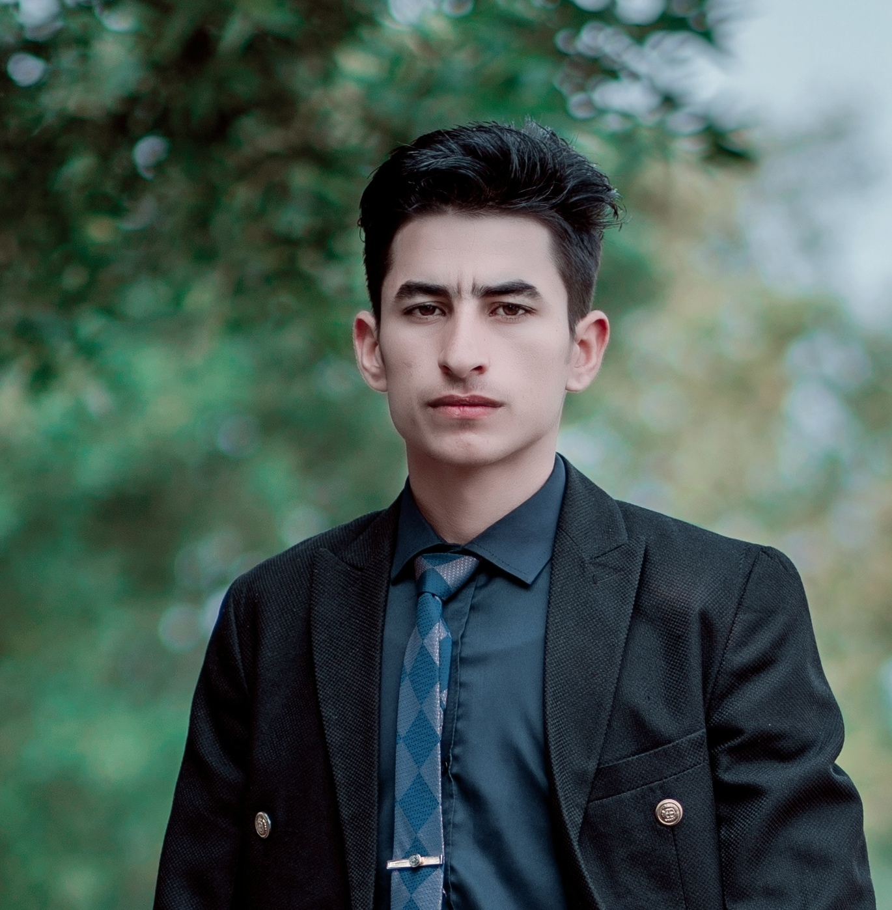 ـ الاســــــــــــــــــــم : مسلم عقيل محمد هويدي   
 ـ الجنـــــــــــــــــس : ذكر**

**ـ الحالة الاجتماعية :متزوج   
 ـ الجنســـــــــــــــية : عراقي**

**ـ الديانة : مسلم   
 ـ تاريخ ومكان الميلاد : 2002 / 1 /1 البشائر   
 ـ العنــــــــــــــــوان : واسط /قضاء الحي /ناحيه البشائر   
 E.MAIL: muslim.eaqil2002@gmail.com   
 ـ اللغة الأم : العربيه ، اللغات الأخرى : الانكليزيه ( قراءة ، كتابة ، تكلم ، فهم )**

**ـ اللقب العلمي: فني**

**ـ الوظيفة الحالية: معيد جامعي**

**2. الشهادات العلمية(المؤهـــــلات الأكاديمية) :**

|  |  |  |  |  |  |
| --- | --- | --- | --- | --- | --- |
| **ت** | **الدرجة العلمية**  **( دكتوراه ، ماجستير ، بكالوريوس )** | **الكلية** | **الجامعة** | **البلد** | **سنة الحصول على المؤهل** |
| **1.** | **دبلوم** | **الجامعه التقنيه الوسطى** | **المعهد التقني كوت** | **العراق** | **1202/2202** |
| **2.** |  |  |  |  |  |
| **3.** |  |  |  |  |  |

**3. الوظائف التي شغلها:**

|  |  |  |  |
| --- | --- | --- | --- |
| **ت** | **الوظيفة** | **تاريخ الالتحاق بها** | **الكلية/الجامعة** |
| **1** | **فني في قسم تقنيات الطاقه المتجدده** | **4202/11/81** | **الجامعه التقنيه الوسطى**  **المعهد التقني كوت** |
| **2** |  |  |  |
| **3** |  |  |  |
| **4** |  |  |  |
| **5** |  |  |  |

**4.**

* **الأستشارات في مجال التخصص:**

|  |  |  |  |
| --- | --- | --- | --- |
| **ت** | **ملخص الاستشارة** | **الجهة المستفيدة** | **السنة** |
| **1.** |  |  |  |
| **2.** |  |  |  |
| **3.** |  |  |  |
| **4.** |  |  |  |
| **5.** |  |  |  |
| **6.** |  |  |  |
| **7.** |  |  |  |
| **8.** |  |  |  |
| **9.** |  |  |  |
| **10.** |  |  |  |

**5 . الـدورات و الموتمرات و ورش العمل :**

|  |  |  |  |  |  |
| --- | --- | --- | --- | --- | --- |
| **ت** | **اسم الدورة/ المؤتمر/ الورشة** | **مكان الانعقاد** | | | **تاريخ انعقادها** |
| **الكلية** | **الجامعة** | **البلد** |
| **1.** |  |  |  |  |  |
| **2.** |  |  |  |  |  |
| **3.** |  |  |  |  |  |
| **4.** |  |  |  |  |  |
| **5.** |  |  |  |  |  |
| **6.** |  |  |  |  |  |
| **7.** |  |  |  |  |  |
| **8.** |  |  |  |  |  |
| **9.** |  |  |  |  |  |
| **10** |  |  |  |  |  |

**6. البـحوث و الدراسات المنجزة المنشورة و التي في الانـجــــــــــا :**

|  |  |  |  |
| --- | --- | --- | --- |
|  |  | **/** | **مجلة النشر** |
| **1.** |  |  |  |
| **2.** |  |  |  |
| **3.** |  |  |  |
| **4.** |  |  |  |
| **5.** |  |  |  |
| **6.** |  |  |  |
| **7.** |  |  |  |
|  |  |  |  |
|  |  |  |  |
|  |  |  |  |
|  |  |  |  |
|  |  |  |  |

**7. المهـــــــــــــــــــــــــــــارات :**

* **التصميم**
* **السباحه**
* **التخطيط**

**8. الهوايــــــــــــــــــــــــــــــات :**

* **السفر**
* **الطبخ**
* **الصيد**
* **التصميم**

**Curriculum Vitae**

  
 **1.**  **Personal information** **:**   
 - **Name: Muslim Aqil Mohammad Hwaidi**

**Wasit / Qadaa Al-Hai / Nahiat Al-Basha'er** - **Permanent Address**

**E.MAIL: muslim.eaqil2002@gmail.com** - **Place and date of Birth:**.2002/1/1 Al-Bashaer  
 - **Place of Residence: Wasit / Al-Hai District / Al-Bashaer Subdistrict**  
- **Nationality: Iraqi**

**- Sex: male**

-  **Social status:Married**

-  **Mother Tongue: Arabic ; Other Language: English (read, write, speak & understand).**

**- Scientific Title :Technical**

**- Current job: Technical in the Renewable Energy Technologies Department**

**2.** **Academic Qualifications:**

|  |  |  |  |  |  |
| --- | --- | --- | --- | --- | --- |
| **No.** | **Degree**  **(PhD ; Mas ; BSC)** | **College** | **University** | **Country** | **Year of qualification** |
| **1.** | **Diploma** | **MiddleTechnical University** | **Al-Kut Technical Institute** | **Iraq** | **2021/2022** |
| **2.** |  |  |  |  |  |
| **3.** |  |  |  |  |  |

**3. Jobs filled:**

|  |  |  |  |
| --- | --- | --- | --- |
| **NO** | **Occupation** | **Joining Date by** | **College / university** |
| **1** | **Technician in the Renewable Energy Technologies Department** | **2024/11/18** | **MiddleTechnical UniversityAl-Kut Technical Institute** |
| **2** |  |  |  |
| **3** |  |  |  |
| **4** |  |  |  |
| **5** |  |  |  |
| **6** |  |  |  |
| **7** |  |  |  |

**4. Experience (academic and specialized):**

**• Teaching in higher education:**

|  |  |  |  |  |  |
| --- | --- | --- | --- | --- | --- |
| **No.** | **Subject**  **Stage**  **Section**  **College / Institute**  **school year** | **stage**  **Stage**  **Section**  **College / Institute**  **school year** | **Section**  **Section**  **College / Institute**  **school year** | **College/Institute** | **Year** |
| **1.** |  |  |  |  |  |
| **2.** |  |  |  |  |  |
| **3.** |  |  |  |  |  |
| **4.** |  |  |  |  |  |
| **5.** |  |  |  |  |  |
| **6.** |  |  |  |  |  |
| **7.** |  |  |  |  |  |

**• Scientific and applied expertise:**

|  |  |  |  |
| --- | --- | --- | --- |
| **Year** | **The beneficiary** | **Summary of experience** | **No.** |
|  |  |  | **1.** |
|  |  |  | **2.** |
|  |  |  | **3.** |
|  |  |  | **4.** |
|  |  |  | **5.** |
|  |  |  | **6.** |
|  |  |  | **7.** |
|  |  |  | **8.** |
|  |  |  | **9.** |
|  |  |  | **10.** |

* **Counseling in the field of specialization:**

|  |  |  |  |
| --- | --- | --- | --- |
| **Year** | **The beneficiary** | **Summary of Counseling** | **No.** |
|  |  |  | **1.** |
|  |  |  | **2.** |
|  |  |  | **3.** |
|  |  |  | **4.** |
|  |  |  | **5.** |
|  |  |  | **6.** |
|  |  |  | **7.** |
|  |  |  | **8.** |
|  |  |  | **9.** |
|  |  |  | **10.** |

* **Administrative experience:**

|  |  |  |  |
| --- | --- | --- | --- |
| **Year** | **The beneficiary** | **Summary of Administrative experience** | **No.** |
|  |  |  | **1.** |
|  |  |  | **2.** |
|  |  |  | **3.** |
|  |  |  | **4.** |
|  |  |  | **5.** |
|  |  |  | **6.** |
|  |  |  | **7.** |
|  |  |  | **8.** |
|  |  |  | **9.** |
|  |  |  | **10.** |

**5.**  **Courses, conferences and workshops** **:**

|  |  |  |  |  |  |
| --- | --- | --- | --- | --- | --- |
| **No.** | **Courses, Conferences / workshops Name** | **Place** | | | **Date of session** |
| **College** | **University** | **Country** |
| 1. |  |  |  |  |  |
| 2. |  |  |  |  |  |
| 3. |  |  |  |  |  |
| 4. |  |  |  |  |  |
| 5. |  |  |  |  |  |
| 6. |  |  |  |  |  |
| 7. |  |  |  |  |  |
| 8. |  |  |  |  |  |
| 9. |  |  |  |  |  |
| 10. |  |  |  |  |  |
|  |  |  |  |  |  |
|  |  |  |  |  |  |
|  |  |  |  |  |  |
|  |  |  |  |  |  |

**6. Research & Studies were published & in achievement :**

|  |  |  |  |
| --- | --- | --- | --- |
| No. | **Research /study Title** | Single / Shared | Publishing Journal |
| 1. |  |  |  |
| 2. |  |  |  |
| 3. |  |  |  |
| 4. |  |  |  |
| 5. |  |  |  |
| 6. |  |  |  |
| 7. |  |  |  |
| 8. |  |  |  |
| 9. |  |  |  |
| 10. |  |  |  |
|  |  |  |  |

**7. skills :**

* **Design**
* **Swimming**
* **Planning**

**8.**  **The Hobbies :**

* **Cooking**
* **Hunting**
* **Design**
* **Travel**